**Tasks**

The visualization, titled "Number of Unauthorized Immigrants and Their Share of the Population in Each State" is designed to support several comparative and informative tasks:

**Comparative Analysis:** It enables a straightforward comparison of the frequency of border encounters for individuals from different countries, highlighting disparities in the volume of encounters.

**Pattern Recognition:** Viewers can identify significant patterns in border encounters, notably the predominant proportion of encounters involving individuals from Mexico compared to other countries.

**Quantitative Understanding:** The chart provides a quantitative breakdown, offering precise counts of border encounters by nationality, which helps in assessing the relative magnitude of encounters per country.

**Insight on Immigration Dynamics:** By showing the concentration of encounters among a few nationalities and the relative rarity among others, the visualization underscores the varying impact of immigration issues across different nationalities. This may hint at underlying factors such as geographic proximity, socio-economic conditions, or political situations driving these patterns.

**Highlighting Diversity and Disparity:** The visualization draws attention to the diversity of nationalities involved in border encounters and the significant disparities among them. This insight can prompt discussions on border management policies, resources allocation, and international cooperation on immigration matters.

Viewers will gain an understanding of the distribution and scale of border encounters by nationality, recognizing the complexity of immigration issues and the need for nuanced policy responses.

**Data**

**Source:** The data for this visualization was sourced from the U.S. Customs and Border Protection (CBP) official website, under the "Nationwide Encounters" statistics section (<https://www.cbp.gov/document/stats/nationwide-encounters>).

Concerns and Processing: Actually, I don’t know the meaning for some of the columns, like “AOR (Abbv)” “Demographic”. But since I won’t use that data, I don’t need to process it.

**Design process**

Originally, I decided to draw a pie chart like to show the Proportion of Different Nationalities in All Border Encounters During 2020-2023. But then I found that there are too many countries, which made me change to the bar chart.

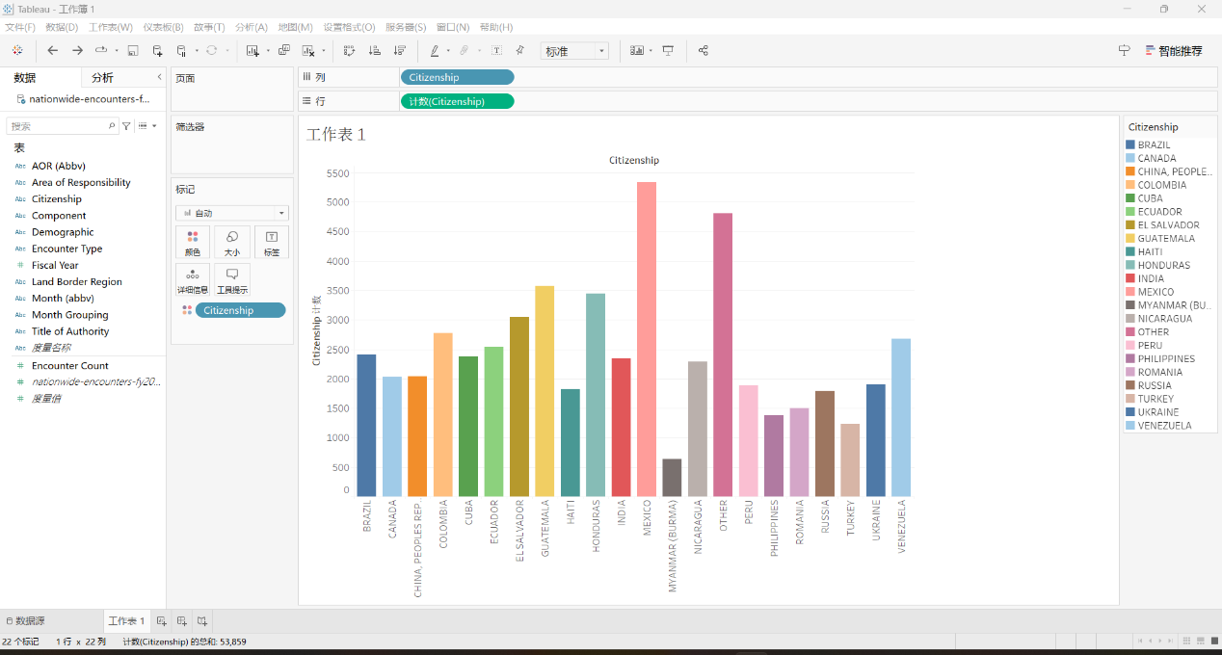

To make the result more intuitive, I delete the ‘Other’ group and sort the values. After adding the title and labels, I got the final version of my plot.

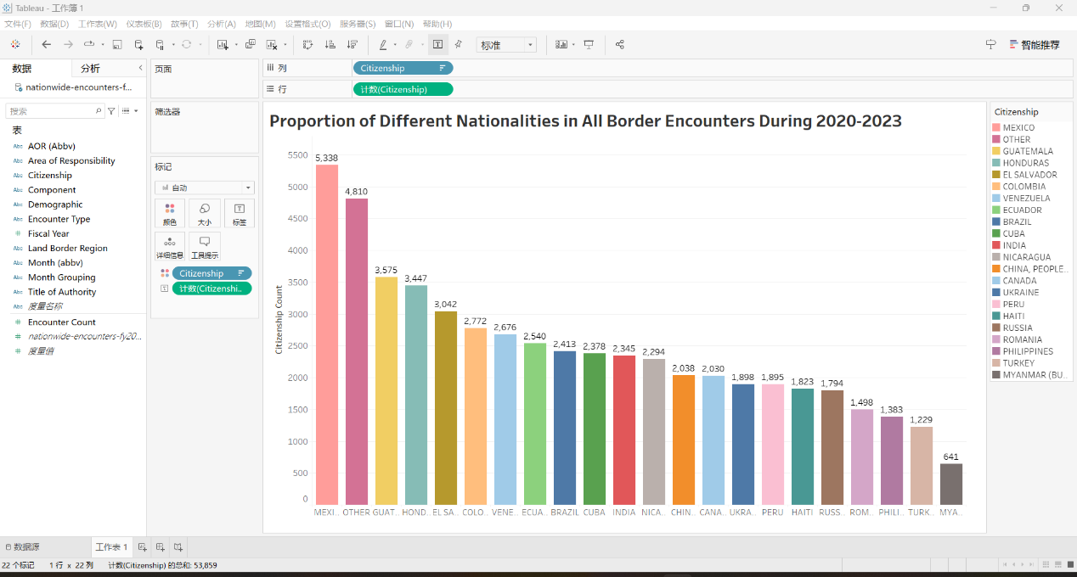

**Qualitative self-evaluation**

**Design and Creation:** My design for illustrating the number and share of unauthorized immigrants effectively balances detail and accessibility, adhering to principles of clear and efficient data representation.

**Effectiveness:** By highlighting disparities and patterns in immigration, the visualization fosters an intuitive understanding of complex issues, showcasing the effective use of visual elements to convey nuanced information.

**Improvement Areas:** Refinement could include further simplifying the data presentation and incorporating interactive elements for enhanced user engagement, aligning with principles of audience engagement and information clarity.

**Class Principles Connection:** This design reflects learned principles of minimizing non-data ink and maximizing the data-ink ratio, yet it underscores the continuous journey towards optimizing data visualization for clarity, accuracy, and efficiency.